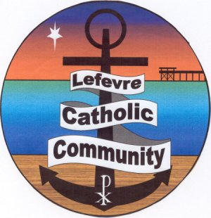

**NINETEENTH CENTURY SCIENCE**

**Fr Julian Tenison Woods in the Philippines**

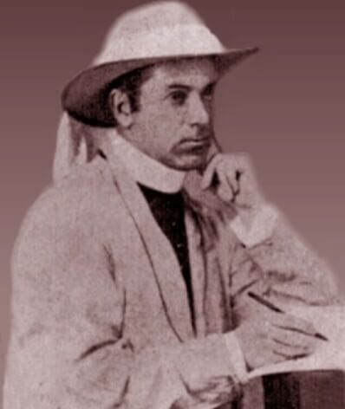

**PIONEER AUSTRALIAN SCIENTIST AND PRIEST FR JULIAN TENISON WOODS VISITED THE PHILIPPINES IN 1884, 1885, AND 1886**

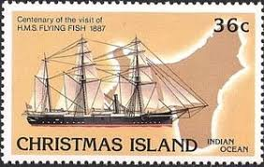

**Nineteenth Century Science was facilitated by the Royal Navy, and Fr Tenison Woods travelled on *HMS Pegasus* and *HMS Flying Fish* for his three visits. He left for us a treasure trove of scientific papers, newspaper articles, and private correspondence with descriptions and analysis of his research. Fr Tenison Woods integrated faith and science in multi-faceted life and ministry.**

**Presented by**

**Fr RODERICK O’BRIEN**

**on Sunday 16 February 2025 from 4:00 – 5.00pm**

**at the Lefevre Catholic Parish Meeting Rooms**

**253 Military Road, Semaphore (adjacent to Sacred Heart Church)**

ENQUIRIES Sr Marie 8449 6378

**A Certificate of Attendance is available for professional development:**

**please register with Sr Marie before the event, and on the day.**